**User Manual**

**“Project Title : Video Tutorial MAnager”**

**Web Programming Laboratory**

**[ CSE 3200]**

**Project Manager: -**

Dr. Kazi Masudul Alam

Associate Professor

Computer Science and Engineering Discipline,

Khulna University.

**Developed By: -**

**Md Rakibul Hasan Molla**

Student ID: 160206

**Swagato Das**

Student ID:160232

**Mahmud Hasan**

Student ID: 150239

Computer Science and Engineering Discipline,

Khulna University.

Date: 29 October 2018



Computer Science and Engineering Discipline,

Khulna University

**Index**

1. **Login**
2. **Dashboard**
3. **Video Adding Page**
4. **Video view page**
5. **Video Comment Reply**
6. **Video View Panel and Related videos Playlist**
7. **Video Search Page**

1. **Login**

To use vtms at first you to log in to our automation side.

This is a Login page. User can log into the site by filling those fields. If any user forgets his password he can recover it.

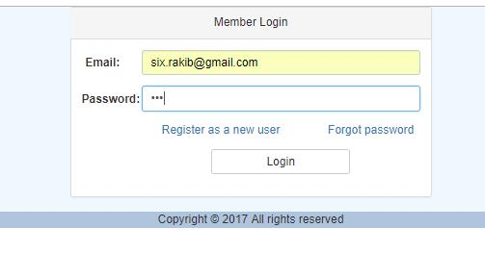

1. **Dashboard**

This is a dashboard page. You have to go to “Manage Video” or “Video Search” to interact with vtms. Amazing options are waiting for you.

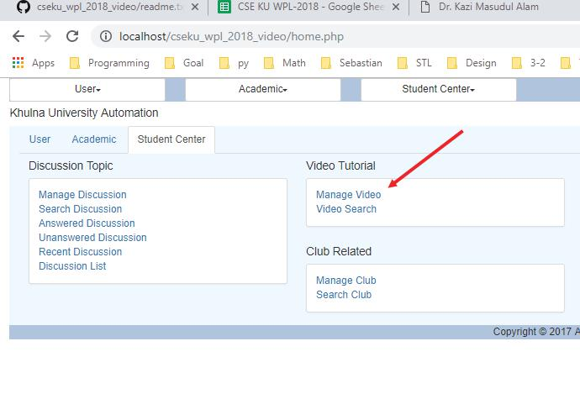

1. **Video Adding Page**

This is actually an uploading or editing page for video. User can add a video by filling these necessary fields.

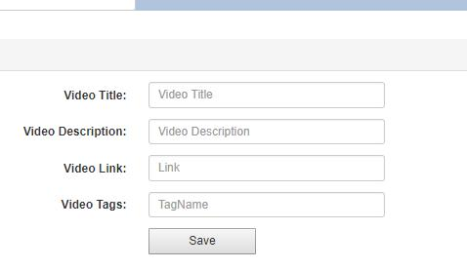

1. **Video view page**

This page helps a user to watch a video. All of the information about this video are shown. In the right-side users can see the related video.

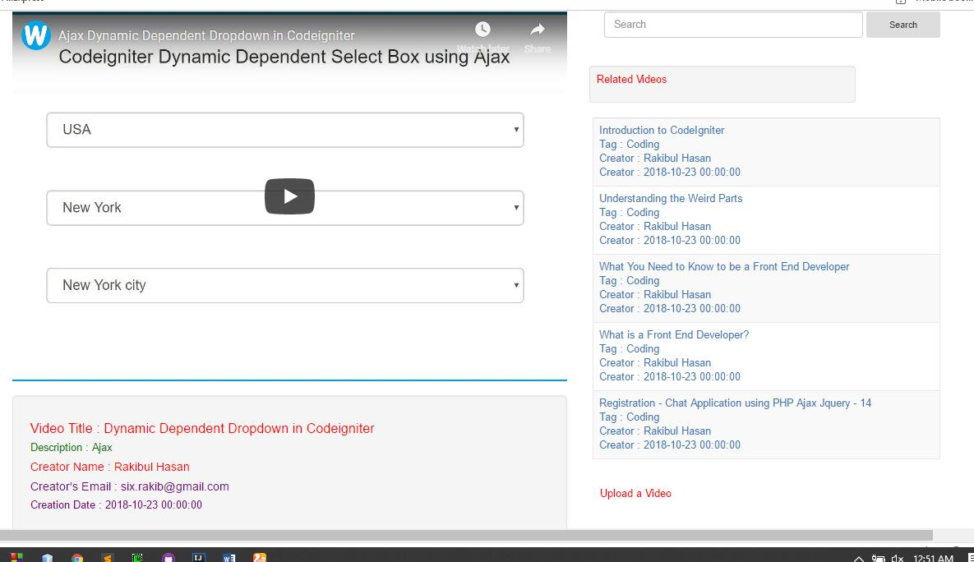

1. **Video Comment Reply:**

In this section user can comment in a video if he wants. Anyone can reply the comment.

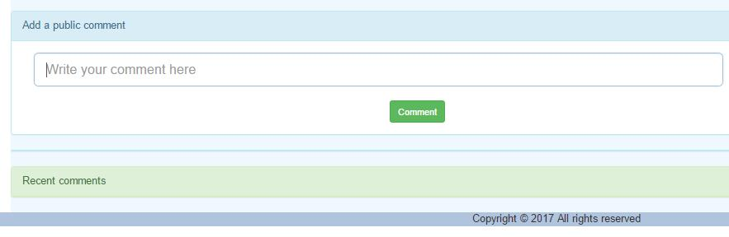

**Blank Comment Check:**

If the comment field is empty the system shows the user to field out the comment field.

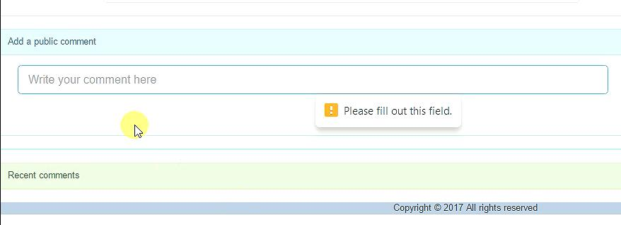

**Reply:**

This is the reply section. Here the user can reply to any comment.

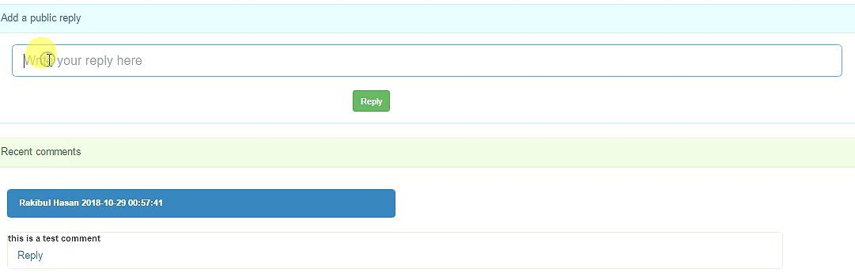

**Reply Tree: (Example 1)**

After replying any comment the reply should be like this as a tree.

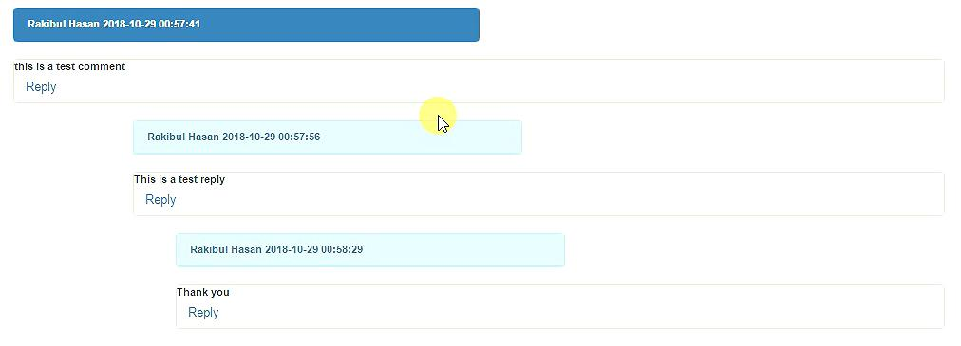

**Reply Tree: (Example 2)**

Here recent comments are shown at first. Then the replies are shown.

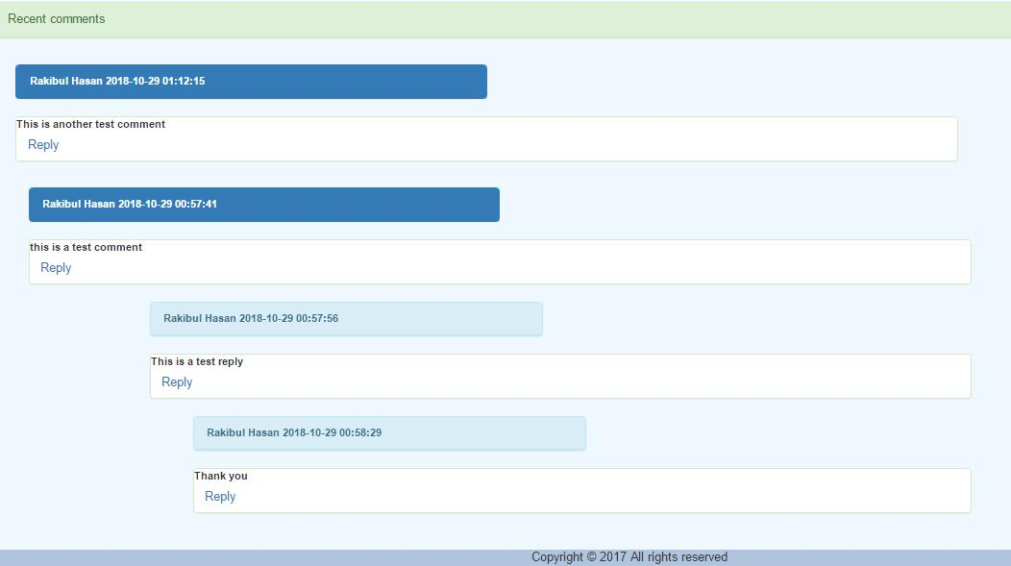

1. **Video View Panel and Related videos Playlist**

In video view panel the user can watch out those types of videos which are related to his video. He can search a video. He can also able to upload a video if he wants. Here are some related videos. User can watch any of it y clicking the video.

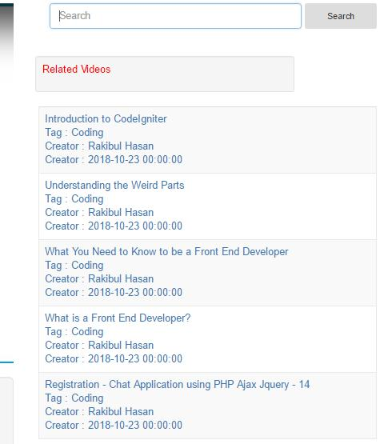

1. **Video Search Page**

In video search page user can search a video by writing the video title or tags.

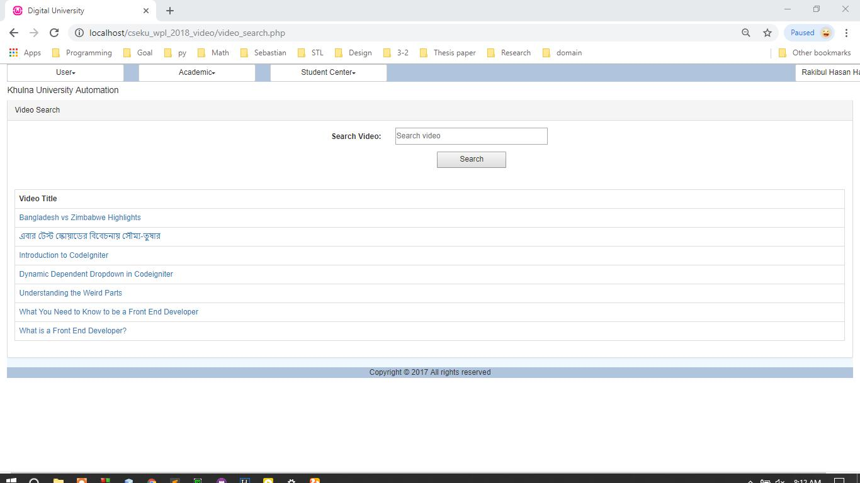

**Tag Search Example**

This is a tags search example. Anyone can search the video by writing the tags of the video.

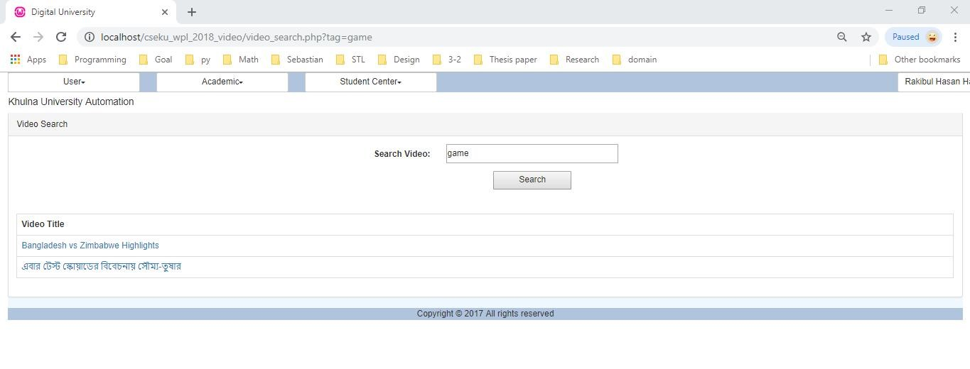**Title Search Example 1**

By searching the title , user can also find his video.

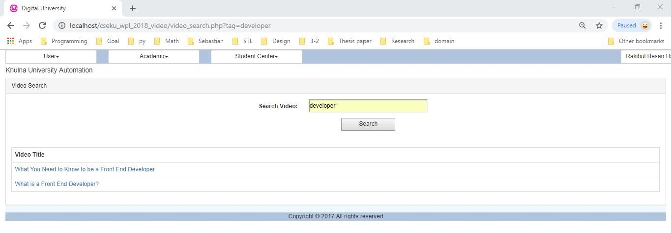

**Tag Search Example 2**

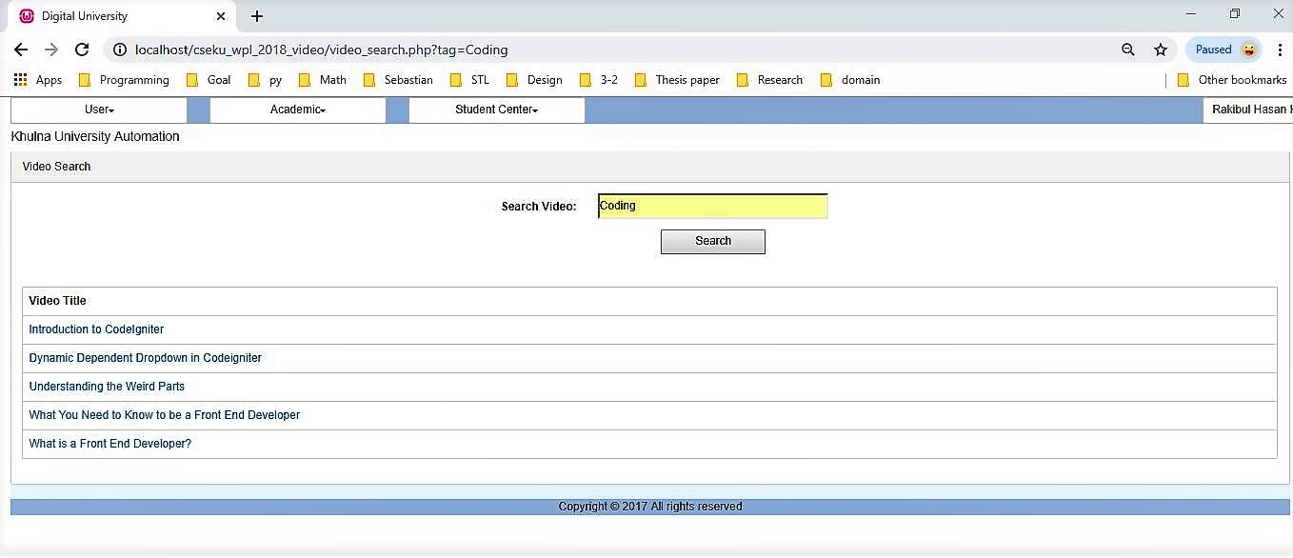

**Thank You**